July Newsletter
Dear Parents,
This month sees the school term come to an end and the summer holiday season begin. If you have any planned holidays, please give Tina the dates so that we know in advance who will not be here.
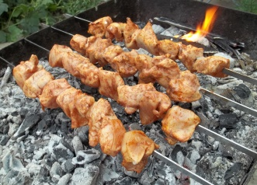
Sports day was a success and (thankfully) the weather held out long enough for it to be a dry(ish) morning. We have now said goodbye to Jane from Microsports and would like to get some feedback as to whether the sports session is something you would like us to continue with, whether you would like something different such as yoga or dance/drama or if you’re not overly bothered if we have anything extra at all. We will need to start thinking about this soon so that we can get a new company in and settled with us for September.
The annual Summer BBQ is getting closer to us! Fingers crossed the weather is amazing for us on the day. If you are planning on coming along on Sunday 24th July with your family, please let Tina know ASAP so that we can ensure we plan enough food for everyone. The cost is £12 per family, covering all meats, buns, soft drinks and the bouncy castle fun.
Last month, we welcomed Ruike to our downstairs classroom and this month we will be welcoming Anandini to our upstairs classroom. I’m sure you’ll all make them feel welcome as only we do at Monique’s.
Although this may seem premature, if your child is starting school in September 2017 and you think you may need after school care, please get in touch with Stef. This September in particular has been very busy which is great for us but not so great for parents needing care. We always try to give preference to those from the nursery needing a place, but we will only reserve a place if we know that you need it!

That’s all for now!!

