Dear parents,
HAPPY NEW YEAR!
I Hope you all had a good break and a lovely time with your family and loved ones. It seems just yesterday that we were all hustling and bustling to prepare for Christmas but now we soon will be saying goodbye to the first month of 2019!
Chinese New Year- We will be celebrating Chinese New Year which is on Tuesday 5th February. Celebrations for Chinese New Year will be celebrated on Monday 4th and Tuesday 5th February. We are very grateful to Linda (Eirene’s mum), Jiayin (Ruilin’s Mum) and Amy (Mina’s mum) who has accepted our request to come to the nursery to participate in the celebration by making Chinese dumplings and noodles with the children!
New addition to the family- We would like to welcome Cassia Dixon to the Monique’s family. She is the same little sister of Beatrix who joined in with her big sister’s group during last year’s Leaver’s Ceremony to give a brilliant performance to ‘Grease lightening’. At that time, she was only about twenty months old but yet she was unfazed with the new faces and environment. She joined in and did the actions to the song as if she had been practising along with all the rest of the performers! We look forward to many more stellar performances from her in the days to come.
Play Ball Sessions- Friday Play Ball sessions have commenced and the children who participated really enjoyed following their coach’s instructions. As true Montessori children, they waited patiently for their turns to try various activities such as catching, throwing and batting a ball and skilfully dodging various obstacles of imaginary trees, flowers and puddles. The children also enjoyed proudly showing their Play Ball stamp, which they got at the end of the session by their coach Emma.
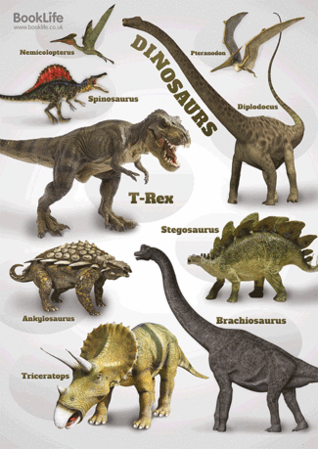
Project- Dinosaur-Following the interests of the children, we have started a project on Dinosaurs. Throughout the project, the children will discover new and interesting facts about Dinosaurs. Therefore, if you have any books or activities at home in relation to this, now is the time to bring them out and discuss them with your child. Watching a documentary about dinosaurs may help you answer some of the questions that your child is likely to have, such as, “Where are Dinosaurs? What happened to them? Why can’t we see any Dinosaurs now? What do dinosaurs eat?”
Appropriate Clothing-The temperature is dropping outside, but at Monique’s we still believe in children going out and playing with water and mud. So, please make sure your child has appropriate warm layers at nursery. This includes named cardigan, named coats, named hats and named gloves. If possible, please send named NECK WARMER as an alternative to the long scarfs/muffler to wrap around your little one’s neck. Also on the matter of Health and Safety, we would like to request parents not to send their babies/toddlers to nursery with small hair clip due to the choking hazard these pose. We would appreciate it if parents could send their child to nursery with shoes and slippers that they can put on themselves - please try to avoid shoe laces and tight fitting, zipped high boots. We believe in ‘helping the child help themselves’ to be autonomous and independent, so dressing them appropriately will help us achieve that.
Winter Progress Report- In the week of 21st January, we will be publishing ‘Winter Progress Report’ of all children. Please can we ask you to take some time to look at it and if possible, write your comments in the comment box. We would like to thank all parents who have contributed their valuable time to post messages and photos on eylog. These is important because it allows the key person to strengthen their bond with their key child, sitting down to talk about the pictures and drawings the child made at home, or explaining a photograph that Mummy and Daddy have posted. This will also add great value it can add to the staff’s knowledge of your child and their development, due to the fact that there are often things that children do with their parents that they do not do at nursery and vice versa.
Dates for your Dairy- We would like to give you as much notice as we can for the inset dates of this year. The first one will be Tuesday April 16. During inset days, children should not attend nursery because these days are solely for the staff for training updates, which as always will be focused on the wellbeing and cognitive development of all the children present in our nursery.
Positive talking – We will have a workshop on ‘Positive Talking’ by Sarah Rowledge. Further details to follow on our email.
Montessori at home
Solution and Mixture -We have introduced the concept of ‘solution and mixture’ to children, so carrying out the following activities at home will help consolidate their learning. Why not let your child go around the garden/kitchen trying to find things that can ‘dissolve’ in water or try using solvents other than water? Initially, we allow the child to just explore, then as the child gets focused on the activity we try to introduce the scientific terms such as ‘dissolve’, ‘solution’, ‘mixture’, ‘super saturated solution’. Maria Montessori always believed that ‘in the mastery of scientific terms, children of three and a half years do better than children of five years’
The toddlers and babies can also join in with this science experiment. The exploration would give them a good opportunity to develop their concentration span, hand-eye coordination and motor dexterity. Being optimistic, it might whet their appetite for Science experiments in future!

That’s all for now

