Dear Parents,
What a couple of weeks’ worth of weather we’ve had! It just goes to show that there is hope yet for our British summer! Now would be a really good time to start bringing in your labelled sun cream bottles and labelled sun hats. The days are changing from warm and sunny to chilly and overcast, so making sure that your child has a range of clothing is important. It allows them to choose which clothing is best for them, helping to promote their own self-care and confidence.
Water – we are trying to encourage the children to take on more water now that the weather is getting warmer. The children will be spending more time outside and going for walks so it’s important for the children to continue to take water on board. One way this can be encouraged is if the children have their own water bottles. This would work particularly well for the school aged leavers, as it will help them get in to the routine of drinking throughout the day. If you would like to, please provide a small labelled drinking bottle (something like 500ml) that the children can refill and keep in their bags on their pegs. Staff will aim to remind children to drink from their bottles throughout the day.
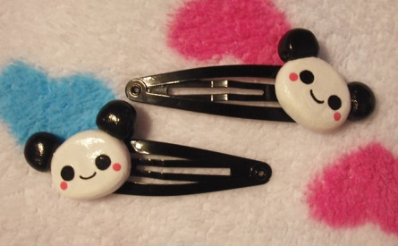
Hair Accessories - We’d like to ask parents to try and not use really small hair clips in their child’s hair. This only really applies to the girls, although we have had boys with clips before. Whilst we are all for keeping hair out of their eyes so they can actually see what they’re doing, the small hair clips very often fall out and are a choking hazard for the younger babies. An alternative could be to use a larger clip/grip. The small clips very often don’t stay in for the children under 1.5/2 years old as their hands go everywhere.
Transport project – the downstairs children are currently doing a project themed around transport and the many different forms of it. Next week, the 3 and 4 year olds will be fortunate enough to be going on a bus trip, where they will pay the conductor and receive a bus ticket for their journey. The bus will take the children on a round route to Westerham and then back again.
Holiday dates – Please be sure to pass on any holiday dates/absences to Tina so that she can note it down in the day books. It’s really important, especially as the weather improves enough for impromptu walks in the mornings, so that we are not calling you asking where your child is when you’re having a lovely trip to see the Grandparents for example.
Summer BBQ – I’ve looked at all the votes for the summer BBQ and I can confirm that the 2017 summer BBQ will be held on……..Sunday 16th July. I am sorry if this means you are unable to attend. Hopefully you have been given enough notice to save the date in your diaries.
Surestart Childrens’ Centre – The Sevenoaks District Sure Start Centre has a number of COMPLETELY FREE classes/groups for parents ranging from music classes (Bounce and Rhyme) and development check sessions, to Introducing Solids groups and Stay and Play groups. There is access to their timetable in the parents section of the website labelled “Sevenoaks Sure Start”, where you’ll be able to find more information on what is available and where. Please make the most of these sessions; they are a great way to meet new parents in the area and you may get some useful tips and ideas for your little ones, you never know.
Sainsbury’s Vouchers – Please keep these vouchers coming! Even those crumpled up ones at the bottom of your handbags, or the ones squished in your pockets with all those receipts. We are edging closer to our goal of 2,000 vouchers and it would be amazing to actually reach that target.

That’s all for now!

