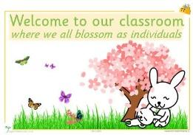
Dear Parents,
We would like to extend a big welcome to our new children and their families who began their journey with us at the start of September. We aim to help Owen, Ruilin, Isabelle and Amelia settle in as quickly as possible by working to understand the way they learn and develop, as well as their likes and dislikes. Please bring in any photos of your family for the Key Person of your child so that we can make your child feel at home by showing and talking about the people and pets they love and care about.
Leaving Ceremony: September is a sad yet exciting time of the year when our school goers take a big step forward in their lives and move onto primary school. As is tradition, we celebrated with a memorable and fun leaving ceremony on the 4th of September. We wish Isabella, Beatrix, Christiaan, Logan, Eithan, Alysia and Sophia the very best of luck and success at their new school and beyond. We look forward to hearing from them soon and hope they will come back to visit.
Sadly, we also said goodbye to Sarah Rose Phillips who moved on to another nursery near her residence. The staff and the children will miss her very much and we wish her all the best in her new endeavour. We are in the process of interviewing potential candidates for the role, but please be assured that the quality of care and education we provide the children will continue to be our top priority.
French Lessons: We would like to welcome our new French teacher, Gatling, who will be giving French lessons to all children every Friday afternoon. Lessons will last 30 minutes for the 2019 batch of school goers and 15 minutes each for the 2020 batch and the babies-toddlers group. If you do not wish for your child to take part in French lessons, please let your Key Person know.
Inset Day: Friday, 19th October is our Inset day so please make alternative arrangements for your childcare as children should not attend the nursery on this day. We apologize for the inconvenience, but the time will be used effectively for in-house staff training on new activities for the toddlers upstairs, whilst the downstairs staff will be planning and preparing for the this year’s Christmas Nativity Play.
Montessori at Home:
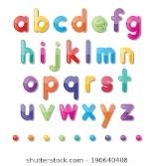
- Literacy: Why not make the most of the last sunshine and warm days of this year by playing ‘letter hunt’ with your child. Just like an egg hunt, hide some letters around the garden and ask your child to find the letter. For beginners, it would be best to start with the letters in their name. However, please make sure to sound out the letter in its lowercase form instead of saying the name of the letter. Your child could even take the letters around the garden and match them to objects e.g. ‘t’ by a tree, a ‘d’ by the dog, or a ‘c’ by the car etc.

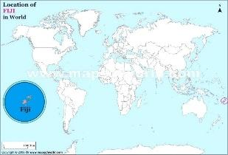
- Understanding the world: Let’s track Stef on the globe as she travels around the world! Her first destination is Fiji, so try finding Fiji with your child on the world map or on a globe. A globe would be the better option as it will give your child some idea of the earth’s shape. I am sure there will be lots of questions coming from your child and you may need to google some answers… so make sure your internet is working!

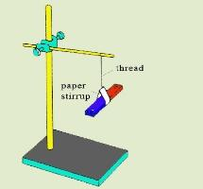
- Science: Hang a bar magnet with the help of some string and let your child swing it before they set off to nursery. When they come back from nursery, let them observe in which direction the magnet is hanging. Here are some points your child could consider: does the magnet always face the same direction? Why? Where is the letter ‘N’ facing? Where is the letter ‘S’ facing? You could even go a step further and introduce a compass to them. Take your child on a walk with the compass and let them find out which direction you all are walking in.

That’s all for now!!

