Dear Parents,

Firstly, we would like to thank you all for the Sainsbury’s’ vouchers that you’ve been bringing in for us. We’ve managed to exceed our target which means that we will be able to get lots of sports equipment for the nursery. This will mean that all children throughout the week will be able to take part in sports activities regularly (if parents would like them to of course). We will keep you updated on how these sports activities will run once we have a “timetable” drawn up and organised. Thank you once again, and if you still have some vouchers lying around, please bring those in as well! Every voucher will help us to get a wider variety of resources.
Holiday Dates: It may be too early to ask, but if you have already planned your Summer Holidays, please can you let us know the dates your child will be absent from nursery. You can either tell Tina in the kitchen or you can e-mail the dates through to us (Moniques.montessori@talktalk.net).

BBQ: We would like to remind you of the Annual Summer BBQ which will be held on Sunday 16th July this year. It’s always a really fun event and the bouncy castles have already been booked for the day. We will give you all more information closer to the time, but please make sure it’s in your diaries. It starts at around 12pm and ends around 4pm, or when everyone has started to head home.
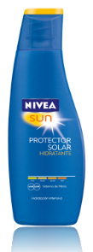
Sun cream: We are entering the time of year when sun cream needs to be applied. Can we please ask that parents apply sun cream to their children first thing in the morning. You can do this in the lobby/garage if you wish, but staff will not be able to do this in the morning. We will however, re-apply sun cream after lunch so it is important that we have sun cream for your child at nursery.
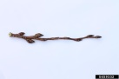
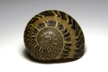
Outdoor Activities: A simple activity you could do with your children is a scavenger hunt. It’s as simple as asking your child to go round the garden looking for items that match a description you give them, for example asking your child to find objects that are brown, or things in the garden that are rough/smooth (other examples include round objects, snail shells, different coloured items, long/short objects etc.). This is a really great way for them to develop and reinforce their senses, encouraging them to look really carefully, feel objects and allows them to collect small objects (something most little ones love doing!).

That’s all for now!!

